**Master 2 internship project**

**Year 2024-2025**

**Laboratory/Institute:** **Institute for Advanced Biosciences**  **Director:** Pierre Hainaut

**Team:** Epigenetics, Immunity, Metabolism, Cell Signaling & Cancer **Head of the team:** Pierre Hainaut

**Research group:** **Chantal Thibert**, Metabolic regulations by LKB1 & p53 in development and diseases

**Name and status of the scientist in charge of the project:**

**Chantal Thibert, CR CNRS HDR: yes**  **no ☐**

**Address:** site Santé, Allée des Alpes, Grenoble 38700 La Tronche

**Phone:** 07 70 15 28 59 **e-mail:** chantal.thibert@univ-grenoble-alpes.fr

**Program of the Master’s degree in Biology:**

**☐** Microbiology, Infectious Diseases and Immunology **☐** Structural Biology of Pathogens

Physiology, Epigenetics, Differentiation, Cancer **☐** Neurosciences and Neurobiology

**Title of the project: Contributions of peripheral nerves to lung cancer cell dissemination**

Objectives: The M2 project will characterize nerve and cancer cells reciprocal communications within lung tumor microenvironment. Using a state-of-the-art *ex vivo* 3D model of peripheral nerve and tumor (spheroid) co-culture, the project will notably characterize how activities of the metabolic regulators LKB1 and p53 in Schwann cells modulate lung cancer cell migration/invasion.

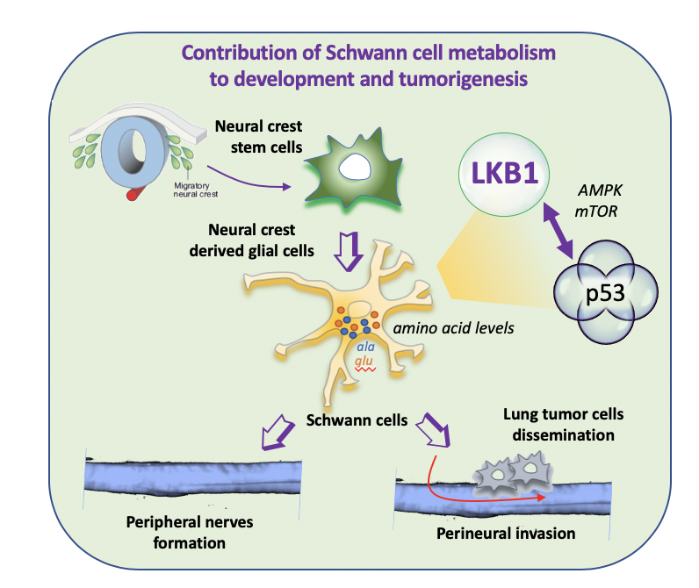Abstract: Peripheral nerves, notably Schwann cells associated to axons, favor cancer cell metastasis through their dissemination along nerves. Tumor innervation is therefore a bad prognostic factor as well as a cause of neuropathy pain experienced by patients. The underlying molecular mechanisms of PNI are so far underexplored, especially the metabolic contributions. Our research hypothesis is that specific Schwann cell fate and metabolic status contribute to PNI. Indeed, Schwann cells exert essential metabolic and trophic support to neurons and dedifferentiate during PNI. We recently uncovered the LKB1 kinase pathway as one major regulator of Schwann cell fate and metabolism, through the control of pyruvate-alanine cycling coupled to mTOR activity (Radu et al, 2019), as well as the limitation of oxidative stress, DNA damage and p53 activity (Lucas et al., in prep). Based on our expertise and on genetically engineered mouse models we generated, the M2 project will explore (in collaboration with a 3rd year PhD student) reciprocal communications between peripheral nerves notably Schwann cells, and cancer cells and impact cancer cell properties, especially proliferation, migration and invasion. The project also aims at identifying drugs targeting metabolic pathways involved in PNI.

Methods: Co-culture of dorsal root ganglia explants with cancer cells as spheroids; primary cultures of neurons and Schwann cells. Validations using Western blot, Immunofluorescence and FACS.

Classical assays to evaluate cancer cell properties of migration and invasion using videomicroscopy, Boyden chambers, healing assays, xCELLigence and IncuCyte technologies….

Metabolic explorations using biochemical amino acid dosages, NMR metabolomics (collab IRMaGe GIN), drug screening (collab CMBA, CEA).

Funding: 6-months internship from the LIGUE contre le cancer association.

Up to 3 relevant publications of the team:

* Lucas A, Radu AG, Torch S, Appaix F, Mével M, Fauvelle F, Blervaque R, Dufour S, Billaud M, Hainaut P, **Thibert C**, LKB1 shapes the enteric nervous system from neural crest progenitors through limitation of oxidative stress and p53 signaling. In preparation.

* Radu AG, Torch S, Fauvelle F, Pernet-Gallay K, Blervaque R, Lucas A, Delmas V, Schlattner U, Tricaud N, Lafenechère L, Hainaut P, Tricaud N, Pingault V, Bondurand N, Bardeesy N, Larue L, **Thibert C**§ and Billaud M.§ LKB1 specifies neural crest cell lineages through pyruvate-alanine cycling. 2019 Science Advances, eaau5106. §co-senior and co-corresponding authors. Work selected for numerous national communications at CNRS and UGA as well as for a Faculty of 1000 communication (F1000 PRIME).

* Creuzet S.,Viallet J., Ghawitian M., Torch S., Thélu J., Alrajeh M., RADU AG**.,** Bouvard D., Costagliola F., Le Borgne M., Buchet- Poyau K., Aznar N., Buschlen S., Hosoya H., **Thibert C**. and Billaud M. (2016) LKB1 signaling in cephalic neural crest cells is essential for vertebrate head development. Dev Biol 418:283-296 - work selected to illustrate the cover image.

Requested domains of expertise: Cell signaling, Tumorigenesis, Cell biology, Biochemistry, Development, Metabolism.